3x3PEER OBSERVATION DEC 2009
TOTAL SCHOOL 74 CLASSES
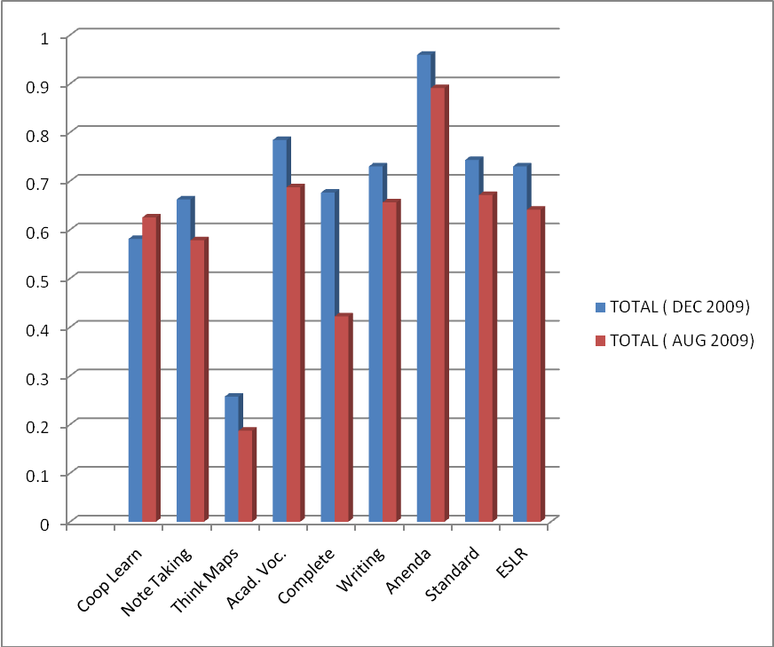

TOTAL |  | Coop Learn |  | Note Taking |  | Think Maps | Acad. Voc. |  | Complete Sentences |  | Writing |  | Agenda |  | Standard |  | ESLR
Dec 09 |  | 58.1% |  | 66.2% |  | 25.7% | 78.4% |  | 67.6% |  | 73.0% |  | 95.9% |  | 74.3% |  | 73.0%
Aug 09 |  | 62.5% |  | 57.8% |  | 18.7% | 68.7% |  | 42.2% |  | 65.6% |  | 89.1% |  | 67.1% |  | 64.1%

